MAT STANDARDS IMPLEMENTATION PLAN: MORAY
This Plan is intended to ensure that services in the Integration Authority area are meeting the standards and the respective criteria for each standard as set out in the Drug Deaths Taskforce report: Medication Assisted Treatment standards: access, choice, support published in May 2021.

Moray MAT Lead | Teresa Green, Mental Health and Drug & Alcohol Service Manager, Health & Social Care Moray.

This Plan has been developed by partners and has taken account of the voices of lived and living experience. The Governance arrangements for local oversight of progress against this Plan, including the role of lived and living experience in this is as follows:

Moray has a multi-disciplinary implementation group taking forward delivery of the MAT standards. Membership includes nursing, medical and mental health staff, social work, third sector and pharmacy representation. There is a sub-group taking forward an improvement project for integrated services pathway redesign using Quality Improvement Methodology, with support from the national MAT Implementation Support Team.

Moray ADP is chaired by the Chief Officer of the Health and Social Care Partnership. Oversight of Drug and Alcohol service delivery and ADP progress is maintained through both H&SC line management and reporting to the IJB as required. The Moray IJB has lived and living experience representation. Developments are underway to strengthen Moray ADPs lived experience participation mechanisms. Moray Chief Officers Group for Public Protection have oversight of Moray ADPs work to reduce drug related deaths, this group is chaired by the Chief Executive of Moray Council and includes the Chief Executive of NHS Grampian, Director of Public Health, Divisional Commander Police Scotland and the Chief Officer of the Health and Social Care Partnership/ADP Chair.

Name | Position | Delivery Partner | Date signed
Simon Boker-Ingram | Chief Officer & ADP Chair | Moray H&SC Partnership | 29/09/2022
Roddy Burns | Chief Executive | Moray Council | 29/09/2022
Caroline Hiscox | Chief Executive | NHS Grampian | 29/09/2022
Kate Stephen | Divisional Commander | Police Scotland A Division | 29/09/2022
Monthly progress review
Delivery Updates
Quarterly progress report
Scottish Government
Assurance/Exception Report
Moray Public Protection Chief Officers Group
Moray Integrated Joint Board
Moray Alcohol & Drug Partnership
Quarterly progress update
Moray H&SC Senior Leadership Group
Board delivery plan report
Voice & participation
Escalation mechanism
Moray Lived Experience Forum/Steering Group
MAT Short Life Working Groups
NHS Grampian MAT Implementation Group
NHS Grampian Board
Moray MAT Implementation Group

This Plan has been signed off on behalf of the delivery partners by:

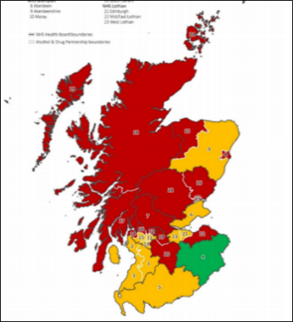 | MAT Standard 1:Same Day Access | Implementation Status |  |  | Apr 22 | Oct 22 | Apr 23
 | All people accessing services have the option to start MAT from the same day of presentation.  This means that instead of waiting for days, weeks or months to get on a medication like methadone or buprenorphine, a person with opioid dependence can have the choice to begin medication on the day they ask for help. | RAG
 |  | Evidence | Data |  | X
 |  |  | Process |  | X
 |  |  | Experiential |  | X
In April 2022 MAT standard 1 was not implemented (red) because there was no evidence that the services in place enable consistent access to same day prescribing for all people or for a defined subgroup.
- Prescribing guidelines required to be updated to enable same day prescribing.
- There was not a standard operating procedure to support the safe initiation of same day opioid substitution therapy
- There was no documented care pathway
- There was no numerical data provided
- No systematic experiential evidence was provided
Actions/deliverables to implement standard 1 |  |  |  | Lead |  | Timescales
NHSG Implementation Group -Update Clinical Framework |  |  |  | FR |  | Dec 2022
NHSG Implementation Group -Develop template for local SOP adaptation. |  |  |  | FR |  | Nov 2022
NHSG Implementation Group -Working group to develop same day prescribing guidelines. |  |  |  | FR |  | Nov 2022
Employ full-time medical cover to provide supervision for non-medical prescribers |  |  |  | BD |  | Complete
Identify Moray GP clinical lead to support further development of D&A/GP protocols |  |  |  | TG |  | ASAP
Employ MIDAS Admin/performance support officer post |  |  |  | TG |  | Delayed
Establish project charter for QI project to determine sustainable solution to same day prescribing barriers |  |  |  | MIST |  | Complete
Establish ToR for Moray MAT1 short life working group/QI group |  |  |  | MIST |  | Complete
Test of change: same day prescribing rota and daily huddle |  |  |  | SLWG |  | Nov 2022
Develop Moray standard operating procedures |  |  |  | SLWG |  | Dec 2022
Develop routine data collection and analysis processes |  |  |  | TG/LC |  | Dec 2022
Develop systematic capture of experiential evidence |  |  |  | EJ/JJ |  | Dec 2022

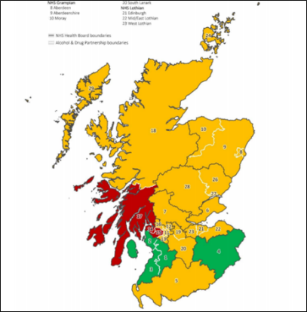 | MAT Standard 2: Choice | Implementation Status |  |  | Apr 22 | Oct 22 | Apr 23
 | All people are supported to make an informed choice on what medication to use for MAT and the appropriate dose.  People will decide which medication they would like to be prescribed and the most suitable dose options after a discussion with their worker about the effects and side-effects. People will be able to change their decision as circumstances change. There should also be a discussion about dispensing arrangements and this should be reviewed regularly. | RAG
 |  | Evidence | Data |  | X
 |  |  | Process |  | ✓
 |  |  | Experiential |  | X
In April 22 MAT standard 2 was partially implemented (amber) because despite having the relevant processes in place to ensure that choice is available, there was no data provided on the uptake or data trends of medication choices, or experiential feedback.
- Process evidence indicated that clinical guidelines include short and long-acting injectable buprenorphine as treatment choices and that all formulations were equally available across all dispensing locations, including a person's home.
- There were standard operating procedures in place for named patient prescribing and good partnership with community pharmacy.
- There was no numerical data provided.
- No systematic experiential evidence was provided.
Actions/deliverables to implement standard 2 |  |  |  | Lead |  | Timescale
NHSG Implementation Group -update clinical framework |  |  |  | FR |  | Dec 2022
NHSG Implementation Group -develop info leaflet |  |  |  | FR |  | Dec 2022
NHSG Implementation Group - working group develop a Methadone Guideline |  |  |  | FR |  | Feb 2023
Develop local information –following NHSG materials |  |  |  | ADP |  | Feb 2023
Update service paperwork to ensure people have been informed of independent advocacy services |  |  |  | TG/JJ |  | Dec 2022
Develop routine data collection and analysis processes |  |  |  | TG/LC |  | Dec 2022
Develop systematic capture of experiential evidence |  |  |  | EJ/JJ |  | Dec 2022

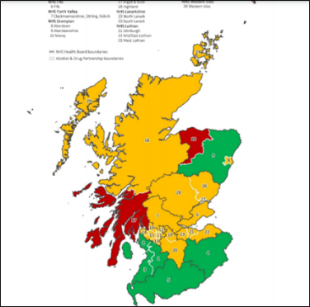 | MAT Standard 3: Assertive Outreach and Anticipatory Care | Implementation Status |  |  | Apr 22 | Oct22 | Apr 23
 | All people at high risk of drug-related harm are proactively identified and offered support to commence or continue MAT.  If a person is thought to be at high risk because of their drug use, then workers from substance use services will contact the person and offer support including MAT. | RAG
 |  | Evidence | Data |  | X
 |  |  | Process |  | X
 |  |  | Experiential |  | X
In April 22 MAT standard 3 was not implemented (red), as there were no documented pathways or processes.
- Assertive outreach occurred locally, but was not a documented process.
- Pathways for near fatal overdose or for people at risk of drug harm were not documented.
- There were significant capacity challenges within Moray to provide outreach services.
- Numerical data provided on incidents of drug harm were not clear around assertive outreach follow up.
Actions/deliverables to implement standard 3 |  |  |  | Lead |  | Timescale
Anticipatory care planning requirement being included in Pan Grampian Clinical Framework |  |  |  | FR |  | Dec 2022
Establish process chart during/following QI workshop for Mat 1/Mat 4 |  |  |  | CL. |  | Sep 2022
Establish ToR for MAT3/4 short life working group (tbc transfer to Operation Protector Partnership) |  |  |  | TG |  | Sep 2022
Establish central SPOC/general email address to triage SAS notifications |  |  |  | LM |  | Dec 2022
Develop Moray wide pathway/process for response to non-fatal overdose/high risk of harm notifications |  |  |  | SLWG |  | Jan 2023
Revise MARs process to explicitly incorporate/refer to assertive outreach and NFO pathway |  |  |  | TG |  | Feb 2023
Develop routine data collection and analysis processes |  |  |  | TG/LC |  | Jan 2023
Develop systematic capture of experiential evidence |  |  |  | EJ/JJ |  | Jan 2023

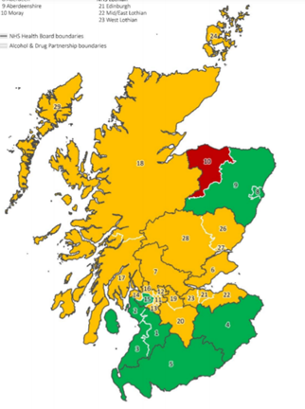 | MAT Standard 4: Harm Reduction | Implementation Status |  |  | Apr 22 | Oct 22 |  | Apr 23
 | All people are offered evidence-based harm reduction at the point of MAT delivery. While a person is in treatment and prescribed medication, they are still able to access harm reduction services – for example, needles and syringes, BBV testing, injecting risk assessments, wound care and naloxone.  They would be able to receive these from a range of providers including their treatment service, and this would not affect their treatment or prescription. | RAG
 |  | Evidence | Data |  | X
 |  |  | Process |  | X
 |  |  | Experiential |  | X
In April 22 MAT standard 4 was not implemented (red) as the core interventions (naloxone, injection equipment, blood borne virus testing) were not consistently available at the same time and place as all MAT appointments
- There were no documented processes in place
- There was no formal process in place for assessing injecting related risk, or guidance on harm reduction advice
- Injecting equipment provision was mainly delivered from the direct access service, and some local pharmacies.
- MIDAS accommodation presents challenges in delivering MAT and harm reduction interventions.
Actions/deliverables to implement standard 4 |  |  |  | Lead |  |  | Timescale
Secure alternative premises for MIDAS –delivery required within a clinical & therapeutic environment |  |  |  | TG |  |  | Delayed
Conduct benchmarking exercise to document all harm reduction processes currently in place |  |  |  | LM/JJ |  |  | Complete
Develop protocol and process for MIDAS delivery of harm reduction during outreach MAT appointments |  |  |  | TG/LM |  |  | Nov 2022
Establish partnership workforce training plan for harm reduction, including wound management |  |  |  | FR |  |  | Dec 2022
Moray wide process/practice standards for all harm reduction interventions -inc wound management |  |  |  | SLWG |  |  | Dec 2022
Develop routine data collection and analysis processes |  |  |  | TG/LC |  |  | Dec 2022
Develop systematic capture of experiential evidence |  |  |  | EJ/JJ |  |  | Jan 2022

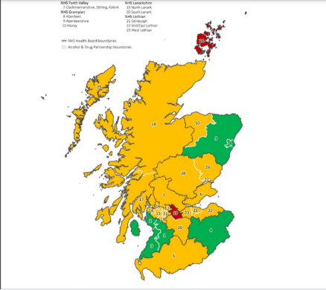 | MAT Standard 5: Retention | Implementation Status |  |  | Apr 22 | Oct  22 |  | Apr 23
 | All people will receive support to remain in treatment for as long as requested. A person is given support to stay in treatment for as long as they like and at key transition times such as leaving hospital or prison. People are not put out of treatment. There should be no unplanned discharges. When people do wish to leave treatment they can discuss this with the service, and the service will provide support to ensure people leave treatment safely. Treatment services value the treatment they provide to all the people who are in their care. People will be supported to stay in treatment especially at times when things are difficult for them. | RAG
 |  | Evidence | Data |  | X
 |  |  | Process |  | ✓
 |  |  | Experiential |  | X
In April 2022 MAT standard 5 was partially implemented (Amber) as documented process evidence were not available to demonstrate different models of care.
- There were no formal service improvement plans in place, and although people were followed up when they disengage with treatment, there was no documented process in place for this.
Actions/deliverables to implement standard 5 |  |  |  | Lead |  |  | Timescale
Anticipatory care planning requirement being included in Pan Grampian Clinical Framework |  |  |  | FR |  |  | Dec 2022
Develop Standard operating procedure for D&A case management in Moray |  |  |  | SLWG |  |  | Oct 22
Establish shared practice standards/anticipatory care for unplanned discharges/non-attendance. |  |  |  | SLWG |  |  | Dec 22
Develop Service Improvement Plans & monitoring/reporting of caseloads, audits & analysis |  |  |  | TG/LC |  |  | Dec 22
Develop routine data collection and analysis processes |  |  |  | TG/LC |  |  | Jan 23
Develop systematic capture of experiential evidence |  |  |  | EJ/JJ |  |  | Jan 23

 | MAT Standard 6: Psychological Support | Implementation Status |  |  | Apr  22 | Oct  22 | Apr 23
 | The system that provides MAT is psychologically informed (tier 1); routinely delivers evidence-based low intensity psychosocial interventions (tier 2); and supports individuals to grow social networks. This standard focuses on the key role that positive relationships and social connection have to play in people's recovery. Services recognise that for many people, substances have been used as a way to cope with difficult emotions and issues from the past. Services will aim to support people to develop positive relationships and new ways of coping as these are just as important as having the right medication. | RAG |  |  | -
 |  | Evidence | Data |  | -
 |  |  | Process |  | -
 |  |  | Experiential |  | -
Self-assessment for MAT standard 6 will be conducted in April 2023
Actions/deliverables to implement standard 6 |  |  | Lead | Timescale
Recruitment of MIDAS Psychologist post |  |  | TG | Complete
Trauma Based Deep Dive |  |  | TG/EJ | Mar 2023
Establish Training Needs Assessment |  |  | TG/EJ | Jan 2023
Establish a staff Training Plan |  |  | TG/EJ | Feb 2023
Develop Psychological Therapies Pathway |  |  | SLWG | Mar 2023
Develop routine data collection and analysis processes |  |  | TG/LC | Jan-Mar 23
Develop systematic capture of experiential evidence |  |  | EJ/JJ | Jan-Mar 23

 | MAT Standard 7: Primary Care | Implementation Status |  | Apr  22 | Oct  22 | Apr 23
 | All people have the option of MAT shared with Primary Care. People who choose to will be able to receive medication or support through primary care providers. These may include GPs and community pharmacy. Care provided would depend on the GP or community pharmacist as well as the specialist treatment service. | RAG |  | -
 |  | Evidence | Data | -
 |  |  | Process | -
 |  |  | Experiential | -
Self-assessment for MAT standard 7 will be conducted in April 2023
Actions/deliverables to implement standard 7 |  |  | Lead | Timescale
NHSG Implementation Group -Refresh of GP Local Enhanced Service Contract |  |  | SR | Dec 23
Further develop shared care protocol with primary care |  |  | SLWG | Jan 23
Review ISA to include Community Pharmacy |  |  | SLWG | Feb 23
Develop routine data collection and analysis processes |  |  | TG/LC | Jan-Mar 23
Develop systematic capture of experiential evidence |  |  | EJ/JJ | Jan-Mar 23

 | MAT Standard 8: Advocacy and Social Support | Implementation Status |  | Apr  22 | Oct  22 | Apr 23
 | All people have access to independent advocacy and support for housing, welfare and income needs. People have the right to ask for a worker who will support them with any help they need with housing, welfare or income. This worker will support people when using services, make sure they get what best suits them and that they are treated fairly. | RAG |  | -
 |  | Evidence | Data | -
 |  |  | Process | -
 |  |  | Experiential | -
Self-assessment for MAT standard 8 will be conducted in April 2023
Actions/deliverables to implement standard 8 |  |  | Lead | Timescale
Update service paperwork to ensure people have been informed of independent advocacy services |  |  | TG/JJ | Dec 2022
Recruitment of Arrows lived experience/recover community development worker |  |  | JJ | Dec 2022
Develop staff guidance and practice standards re offering advocacy and follow up reviews |  |  | TG/EJ | Jan 2023
Monitor and review capacity of Advocacy Service contract |  |  | EJ/TW | Jan-Mar 23
Review referral and support pathway with Housing and welfare benefits service |  |  | SLWG | April 23
Develop routine data collection and analysis processes |  |  | TG/LC | Jan-Mar 23
Develop systematic capture of experiential evidence |  |  | EJ/JJ | Jan-Mar 23

 | MAT Standard 9: Mental health | Implementation Status |  | Apr  22 | Oct  22 | Apr 23
 | All people with co-occurring drug use and mental health difficulties can receive mental health care at the point of MAT delivery. People have the right to ask for support with mental health problems and to engage in mental health treatment while being supported as part of their drug treatment and care. | RAG |  | -
 |  | Evidence | Data | -
 |  |  | Process | -
 |  |  | Experiential | -
Self-assessment for MAT standard 9 will be conducted in April 2023
Actions/deliverables to implement standard 9 |  |  | Lead | Timescale
Recruitment of MIDAS Psychologist post |  |  | TG | Complete
Trauma Based Deep Dive |  |  | TG/EJ | Mar 2023
Establish Training Needs Assessment |  |  | TG/EJ | Jan 2023
Establish a staff Training Plan |  |  | TG/EJ | Feb 2023
Develop Psychological Therapies Pathway |  |  | SLWG | Mar 2023
Develop routine data collection and analysis processes |  |  | TG/LC | Jan-Mar 23
Develop systematic capture of experiential evidence |  |  | EJ/JJ | Jan-Mar 23

 | MAT Standard 10: | Implementation Status |  | Apr  22 | Oct  22 | Apr 23
 | All people receive trauma informed care. The treatment service people use recognises that many people who use their service may have experienced trauma, and that this may continue to impact on them in various ways.  The services available and the people who work there, will respond in a way that supports people to access, and remain in, services for as long as they need to, in order to get the most from treatment. They will also offer people the kind of relationship that promotes recovery, does not cause further trauma or harm, and builds resilience. | RAG |  | -
 |  | Evidence | Data | -
 |  |  | Process | -
 |  |  | Experiential | -
Self-assessment for MAT standard 10 will be conducted in April 2023
Actions/deliverables to implement standard 10 |  |  | Lead | Timescale
Recruitment of MIDAS Psychologist post |  |  | TG | Complete
Trauma Based Deep Dive |  |  | TG/EJ | Mar 2023
Establish Training Needs Assessment |  |  | TG/EJ | Jan 2023
Establish a staff Training Plan |  |  | TG/EJ | Feb 2023
Develop routine data collection and analysis processes |  |  | TG/LC | Jan-Mar 23
Develop systematic capture of experiential evidence |  |  | EJ/JJ | Jan-Mar 23

